

**Faculty of engineering - Shoubra**

**Benha University**

# Research Article / Research Project / Literature Review

in fulfillment of the requirements of

|  |  |
| --- | --- |
| **Department** | **Engineering Mathematics and Physics** |
| **Division** |  |
| **Academic Year** | **2019-2020 Preparatory** |
| **Course name** | **Computer** |
| **Course code** | **ECE001** |

## Title: -

**Mobile Computing**

By:

|  |  |  |  |
| --- | --- | --- | --- |
|  | Name | Edu mail | B.N |
| 1 | Hesham Ahmed Mohamed Diab | hesham196147@feng.bu.edu.eg | 1018 |

**Approved by:**

|  |  |
| --- | --- |
| Examiners committee | Signature |
| DR. Ahmed Bayoumi | 1 |
| Dr. Shady Elmashad | 2 |
| DR. Abdelhamid Attaby | 3 |

# Application Brief

Mobile Computing is a technology that allows transmission of data, voice and video via a computer or any other wireless enabled device without having to be connected to a fixed physical link. This tutorial will give an overview of Mobile Computing and then it will take you through how it evolved and where is the technology headed to in future along with the classifications and security issues involved.

# ScreenShots

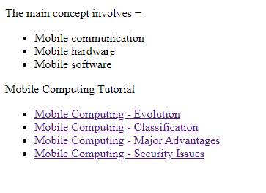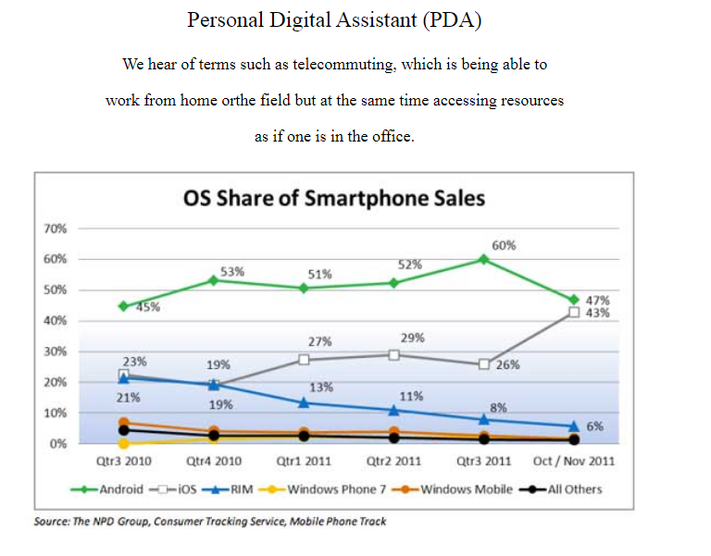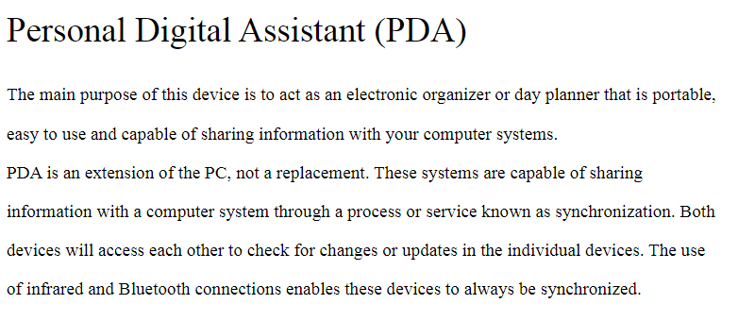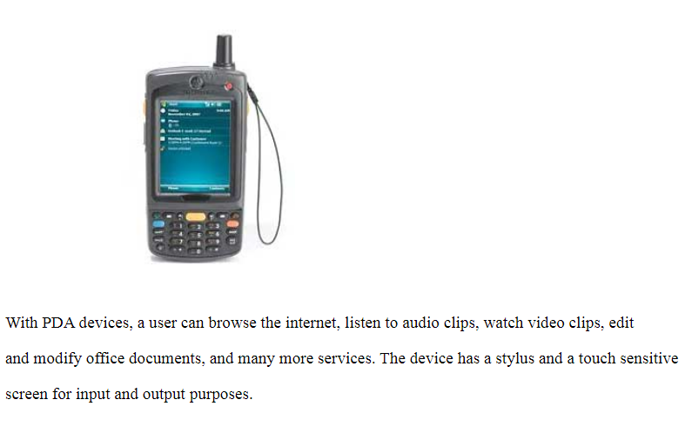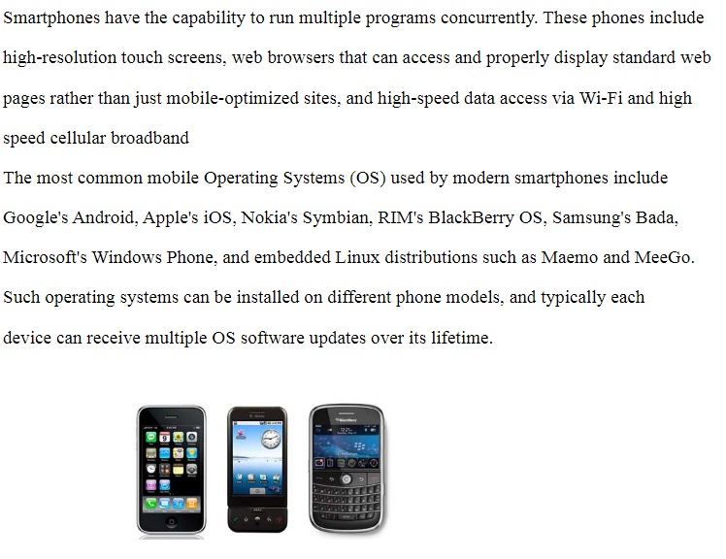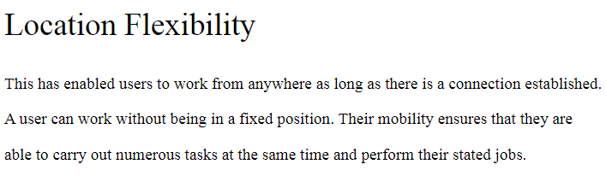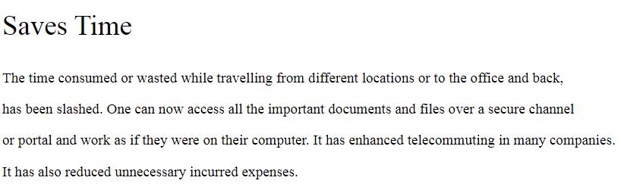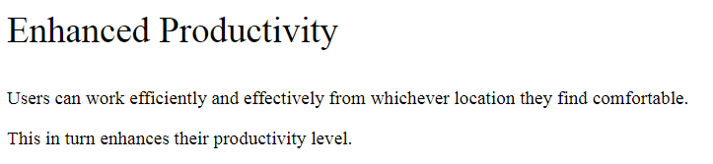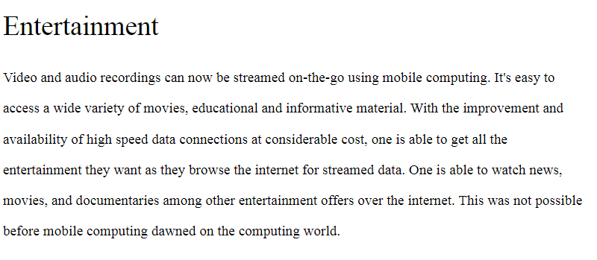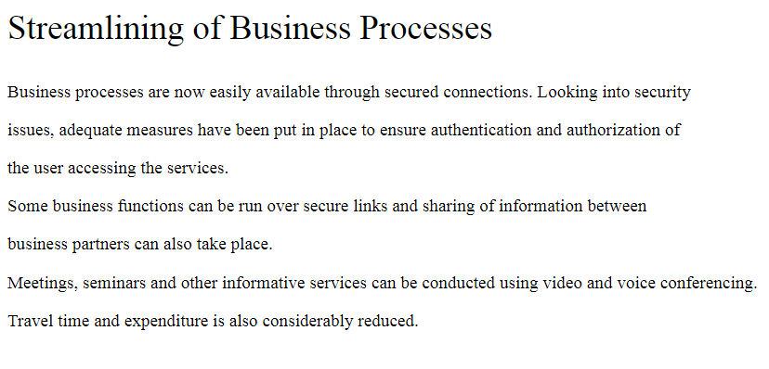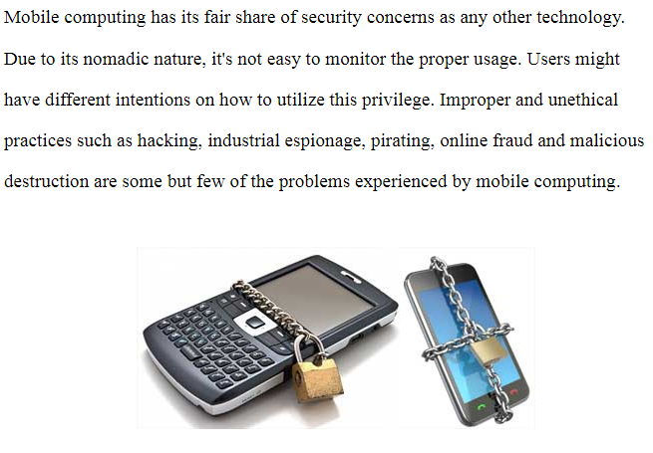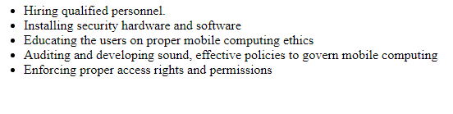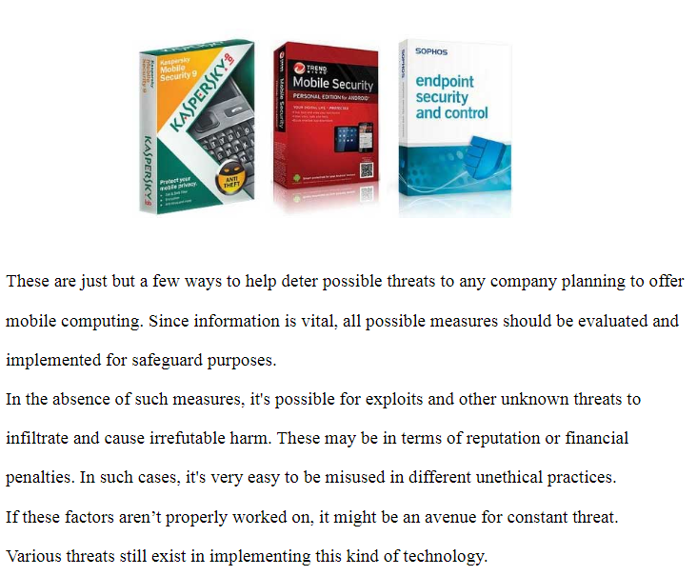

# Source Code

